**Smoothing Filters**

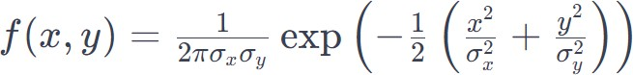**1.Gaussian Filter**

**Code Snippet:**

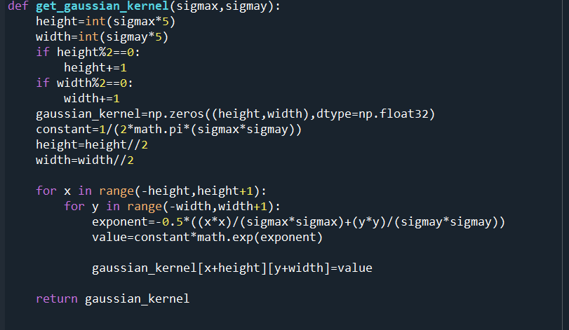

**Output:**

**Grayscale Images:**

The center of the kernel is (1,1)

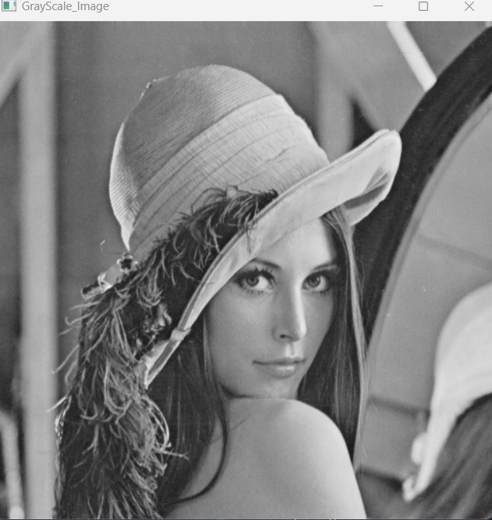 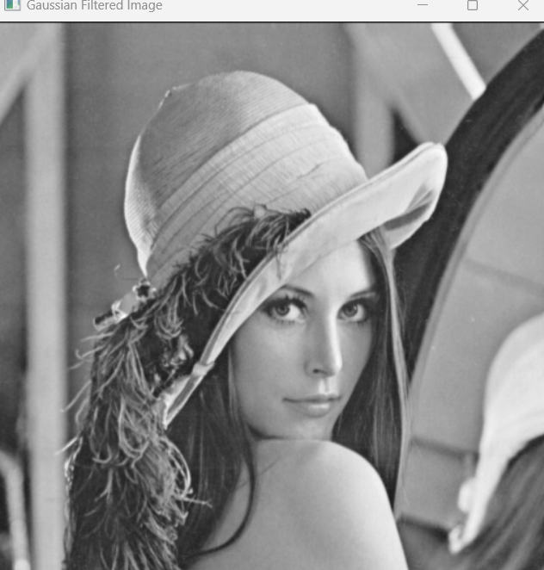

**Fig 1.1:** Grayscale Image. **Fig 1.2:** Gaussian Filtered Grayscale Image.

**RGB Images:**

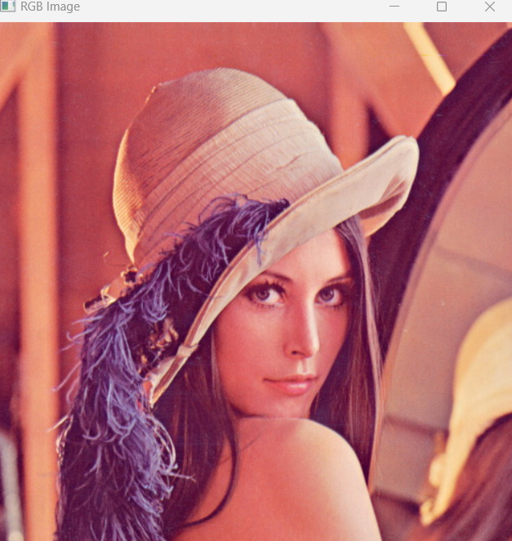 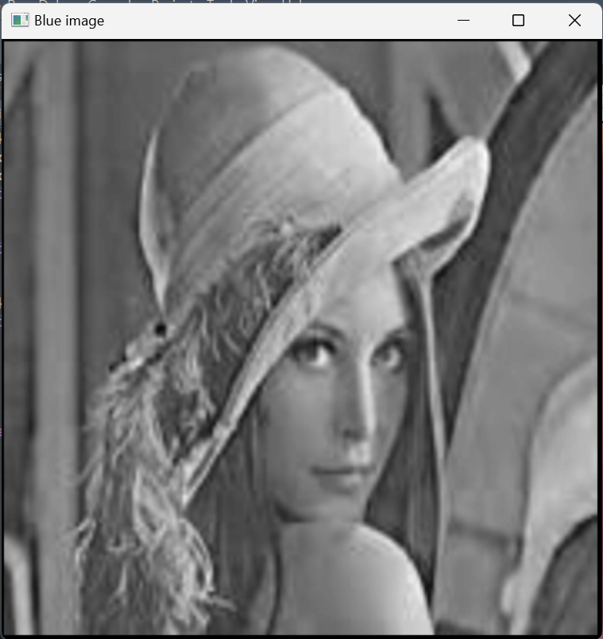

**Fig 1.3:** RGB Image. **Fig 1.4:** Gaussian Filtered Blue Image.

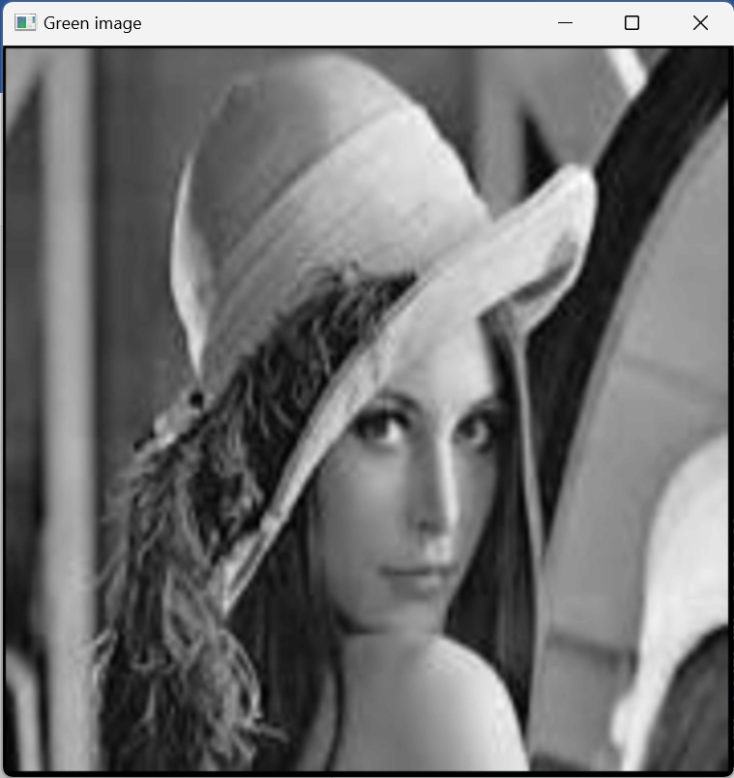 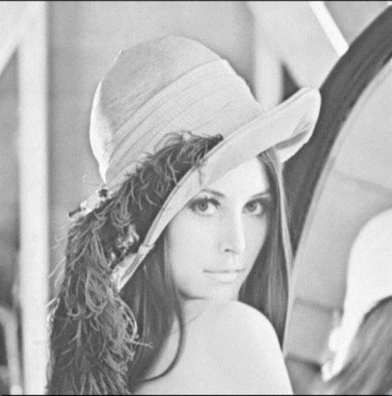

**Fig 1.5:** Gaussian Filtered Green Image. **Fig 1.6:** Gaussian Filtered Red Image.

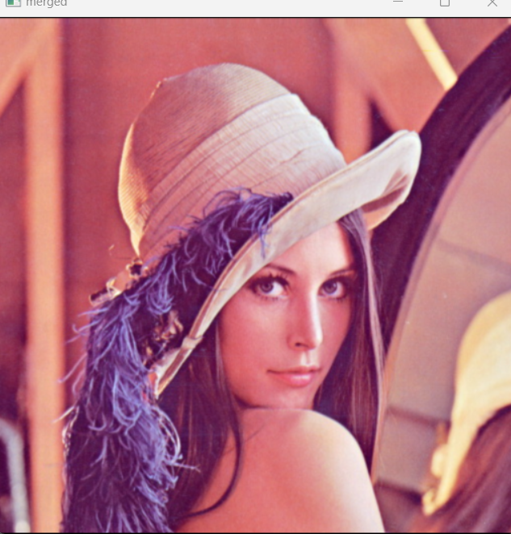

**Fig 1.7:** Gaussian Filtered RGB Image.

**HSV Images:**

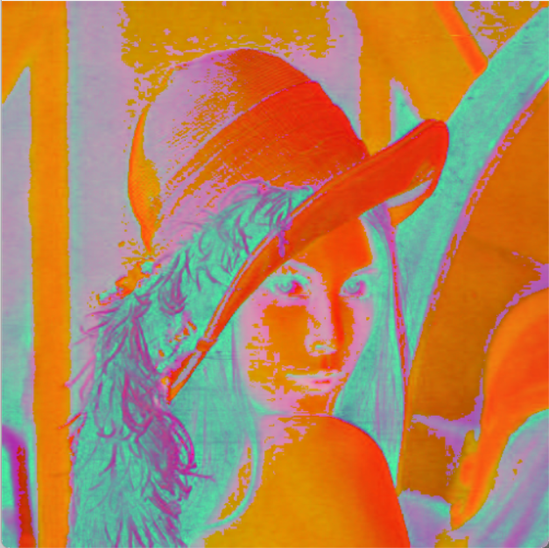 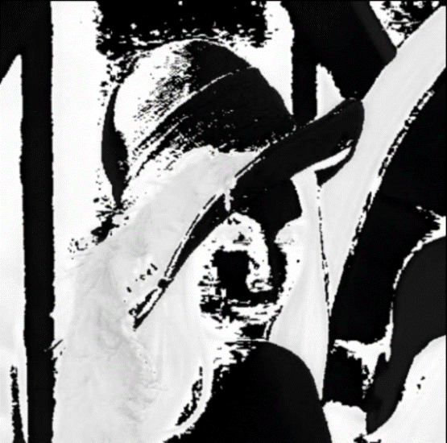

**Fig 1.7:** HSV Image. **Fig 1.8:** Gaussian Filtered Blue HSV Image. 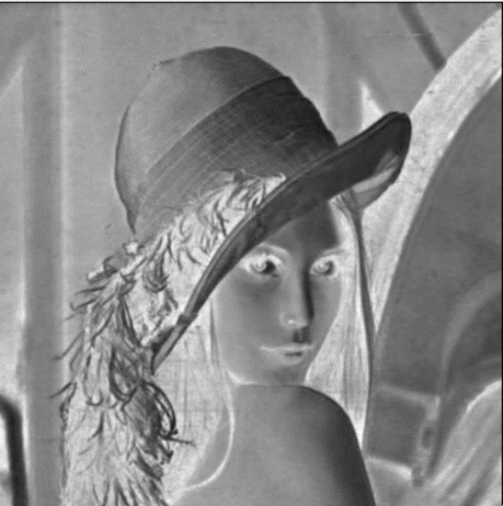 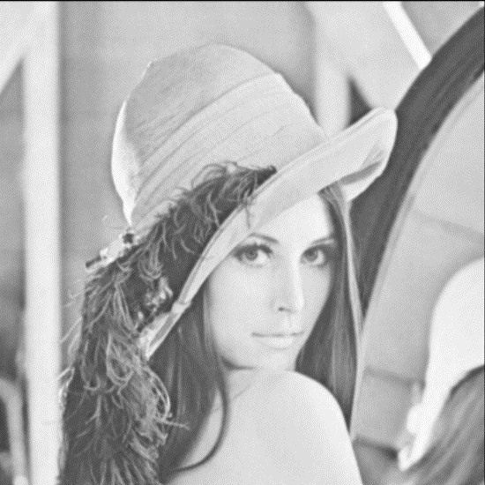

**Fig 1.9:** Gaussian Filtered Green HSV Image.  **Fig 1.10:** Gaussian Filtered Red HSV image.

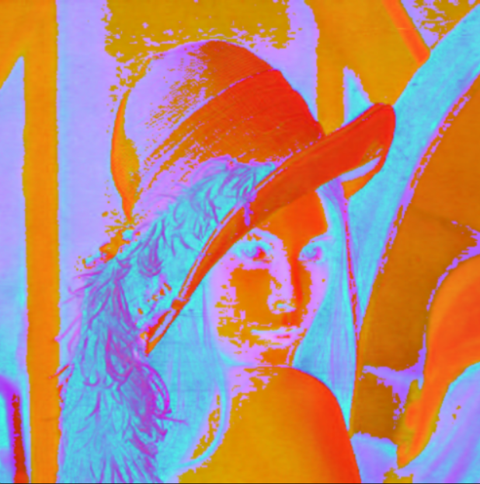

**Fig 1.11:** Gaussian Filtered HSV Image.

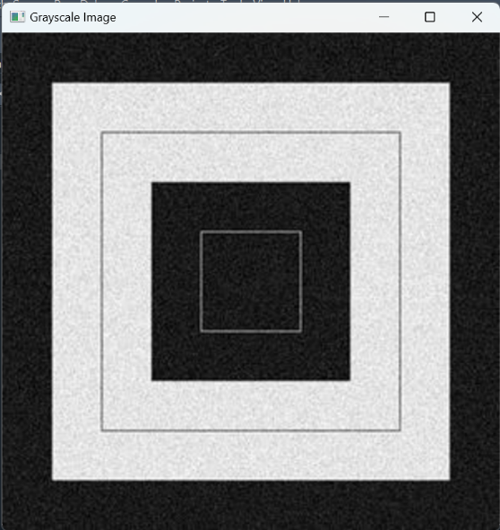 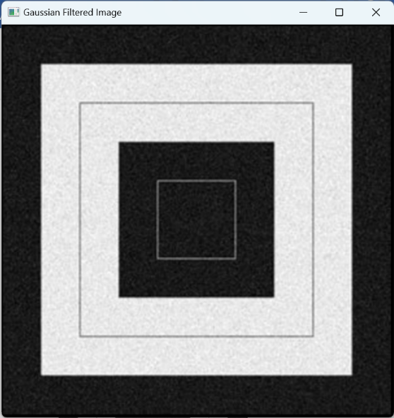

**Fig 1.12:** Grayscale Image. **Fig 1.13:** Gaussian Filtered Grayscale Image.

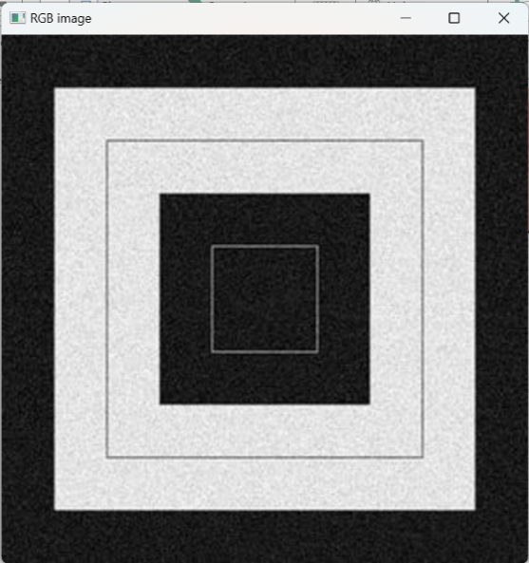 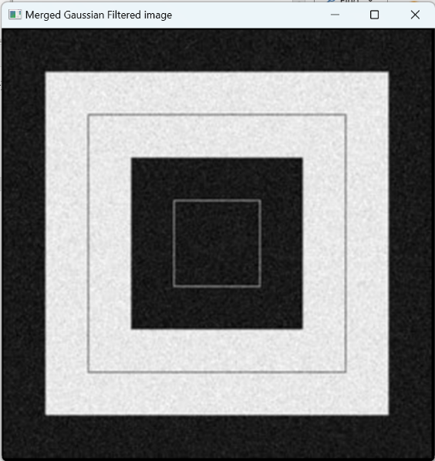

**Fig 1.14:** RGB Image**. Fig 1.15:** Gaussian Filtered RGB Image.

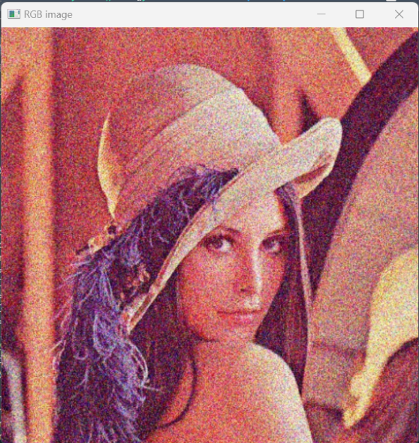 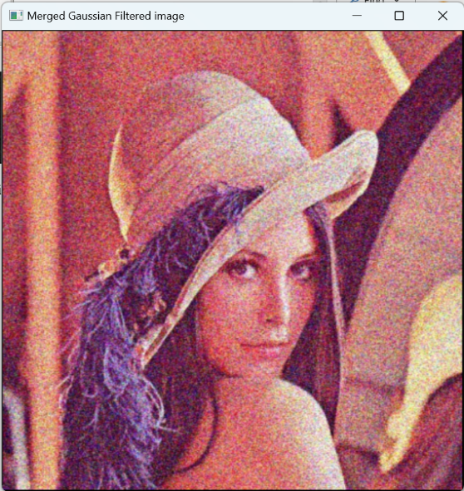

**Fig 1.16:** RGB Image. **Fig 1.17:** Gaussian Filtered RGB Image.

**2.Mean Filter**

**Mean kernel**

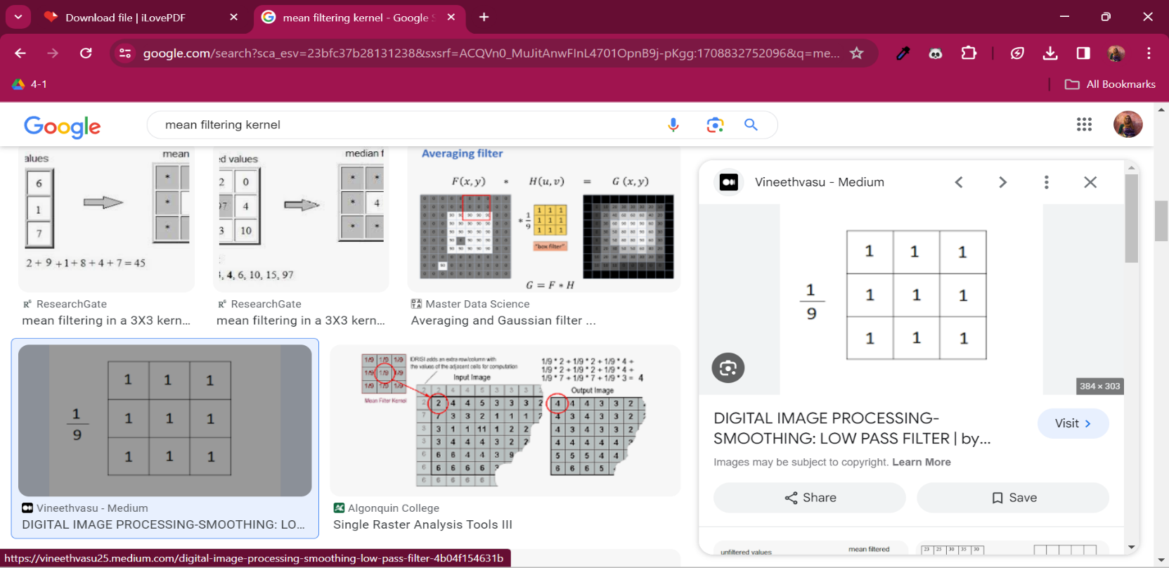

**Code Snippet:**

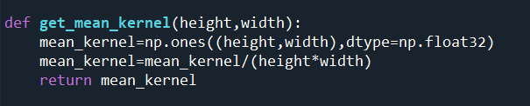

**Output:**

**Grayscale Images:**

The center of the kernel is (1,1).

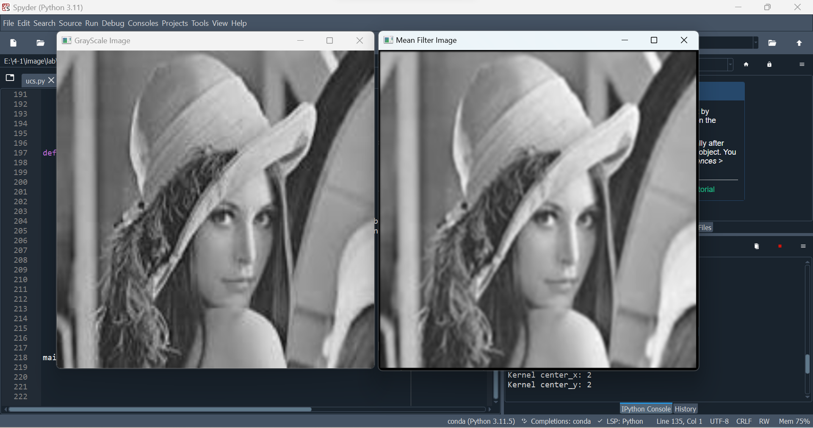 

**Fig 1.18:** Grayscale Image. **Fig 1.19:** Mean Filtered Grayscale Image.

**RGB Images:**

The center of the kernel is (2,2).

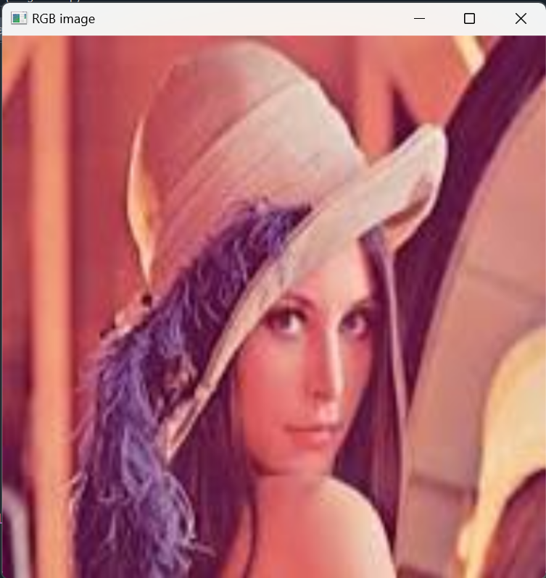 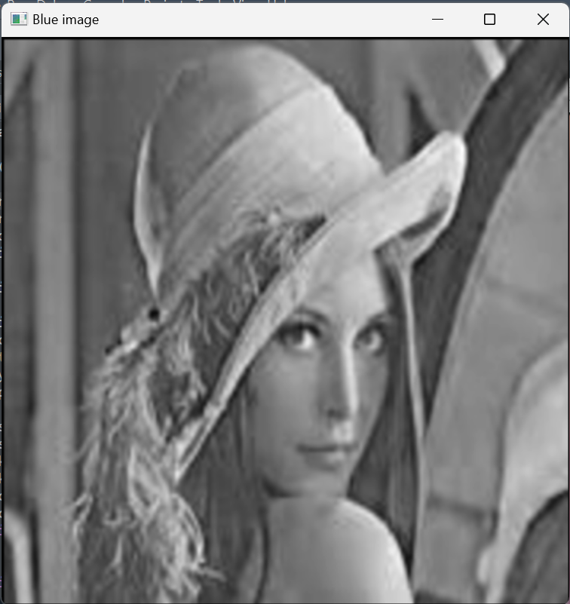

**Fig 1.20:** RGB Image.

**Fig 1.21:** Mean Filtered Blue Image.

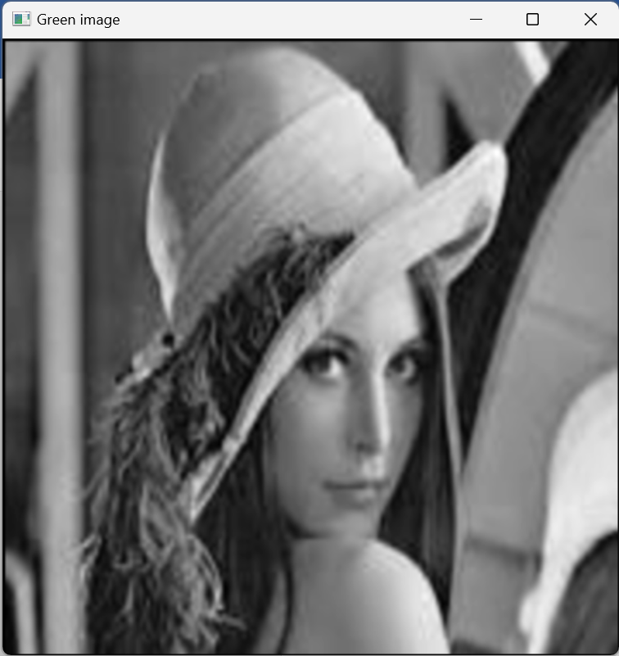 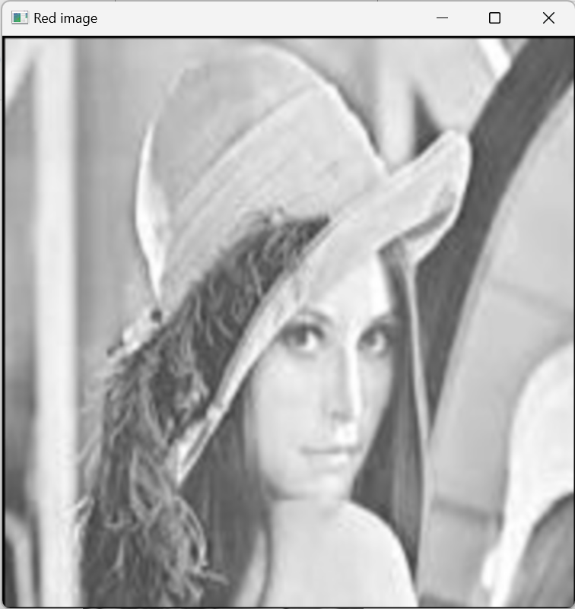

**Fig 1.22:** Mean iltered Green Image. **Fig 1.23:** Mean Filtered Red Image.

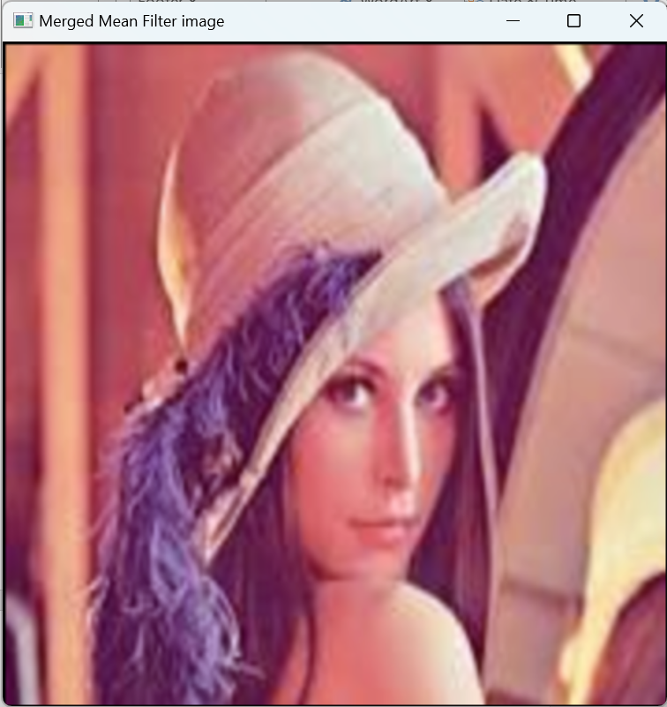

**Fig 1.24:** Mean Filtered RGB Image.

**HSV Images:**

The center of the kernel is (0,2).

 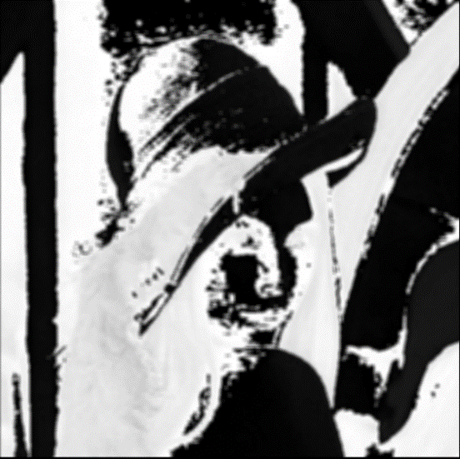

**Fig 1.25:** HSV Image. **Fig 1.26:** Mean Filtered Blue Image.

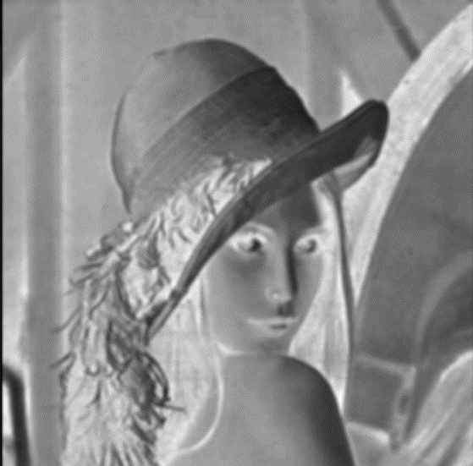 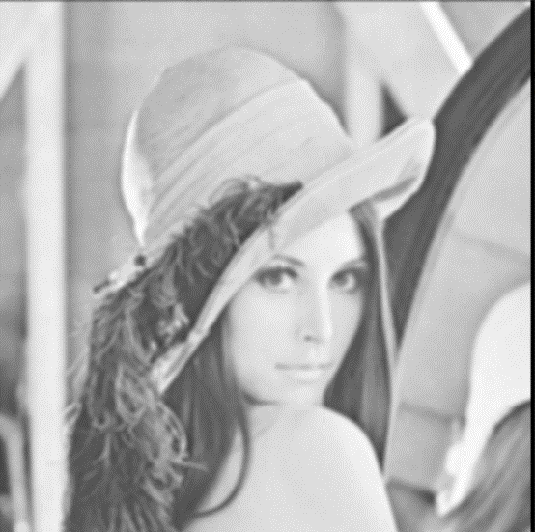

**Fig 1.27:** Mean Filtered Green Image. **Fig 1.28:** Mean Filtered Green Image.

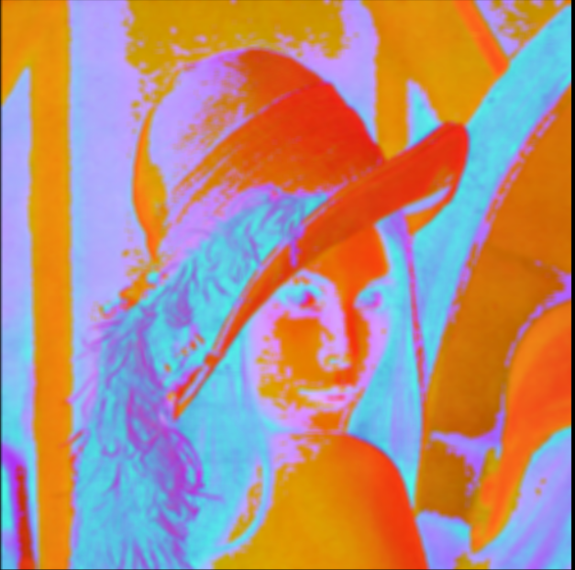

**Fig 1.29:** Mean Filtered HSV Image.

**2.Sharpening Filters**

**2.1 Laplacian Filter**

**Laplacian Kernel:**

|  |  |  |
| --- | --- | --- |
| 0 | 1 | 0 |
| 1 | -4 | 1 |
| 0 | 1 | 0 |

**Code Snippet:**

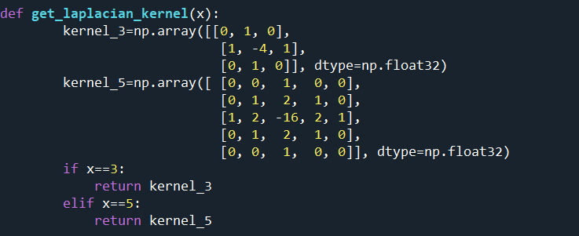

The sum of the elements of each kernel is 0.

**Output:**

**Grayscale Image:**

The center of the kernel is (1,1).

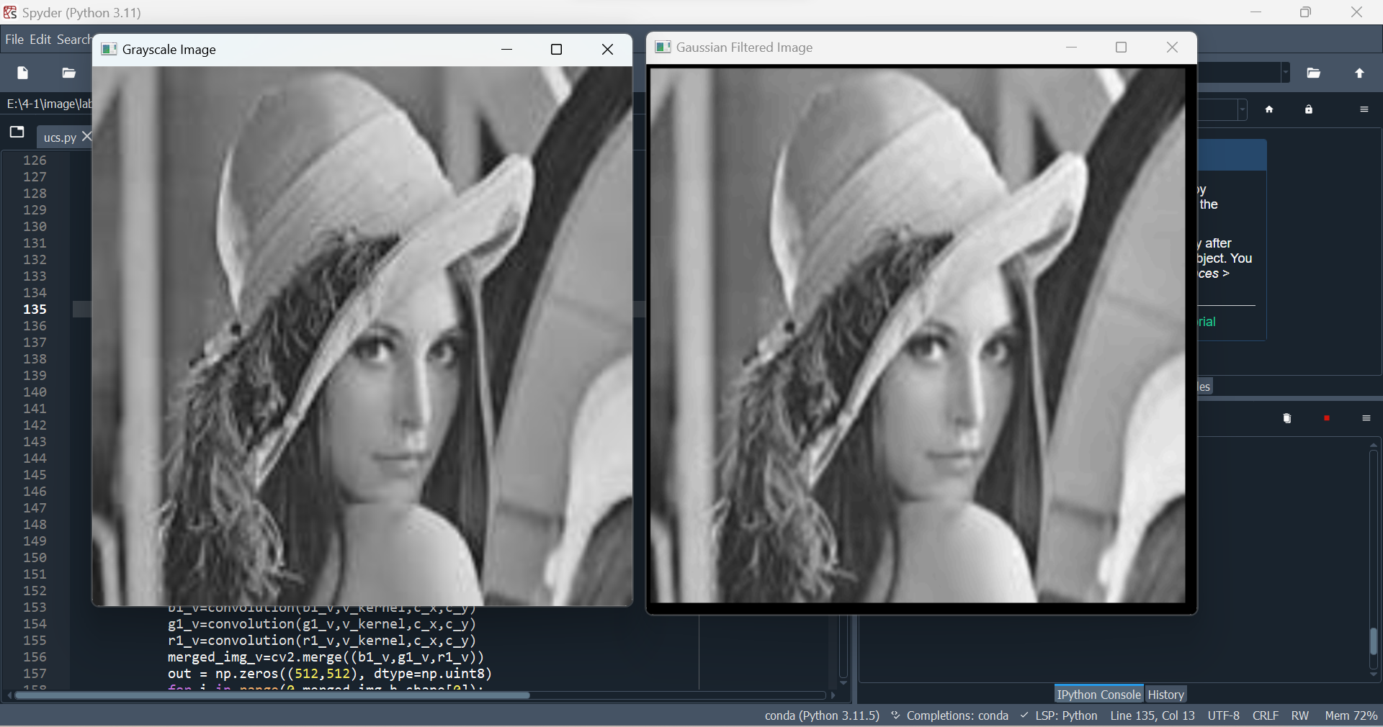 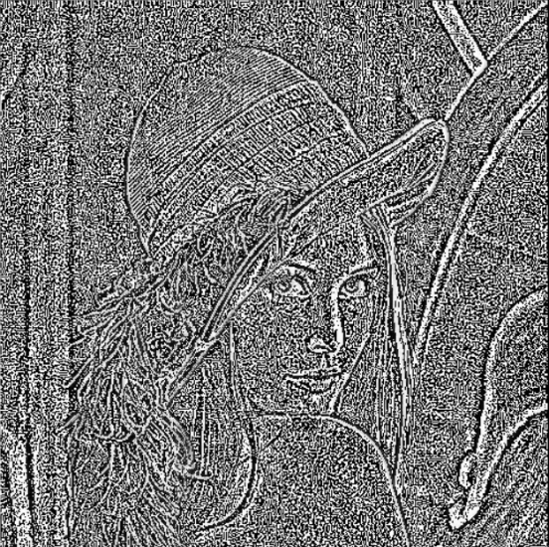

**Fig 1.30:** Grayscale Image **Fig 1.31:** Laplacian Filtered Grayscale Image

For the next example the kernel is 5 by 5 matrix and the center is (2,2).

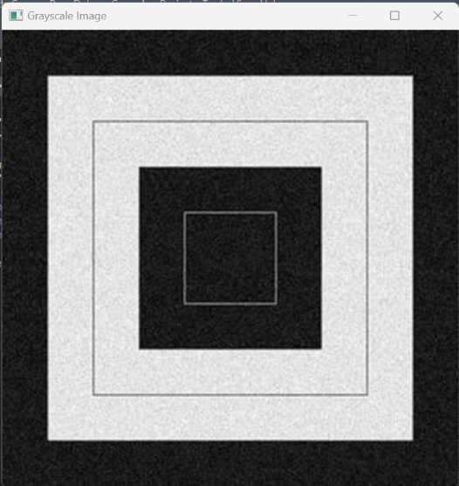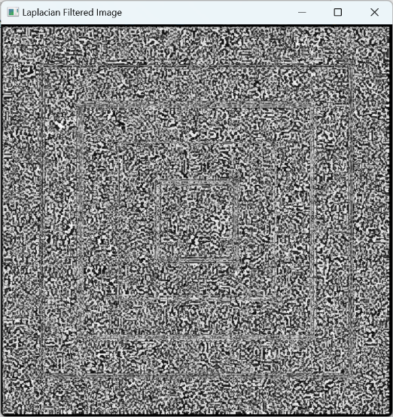

**Fig 1.32:** Grayscale Image. **Fig 1.33:** Laplacian Filtered Grayscale Image.

**RGB Images:**

The center of the kernel is (1,1).

 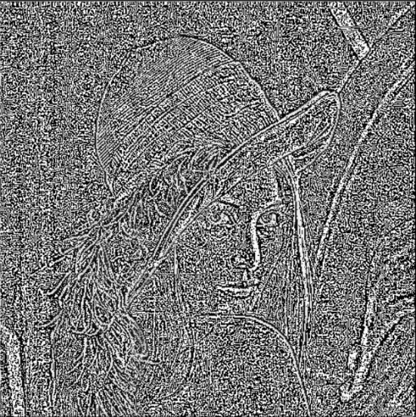

**Fig 1.34:** RGB Image. **Fig 1.35:** Laplacian Filtered Blue Image.

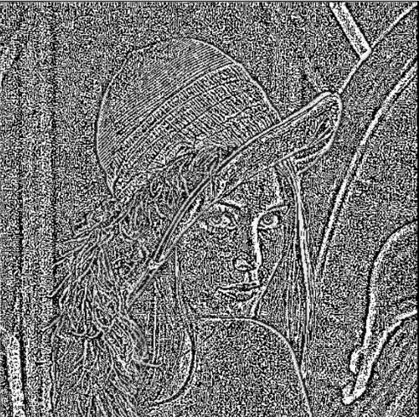 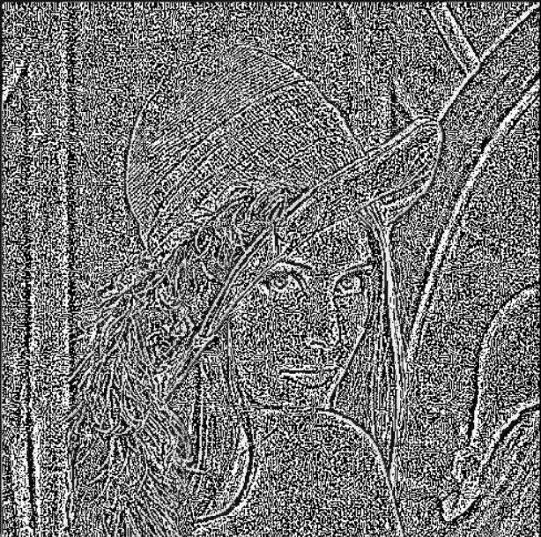

**Fig 1.36:** Laplacian Filtered Green Image. **Fig 1.37:** Laplacian Filtered Red Image.

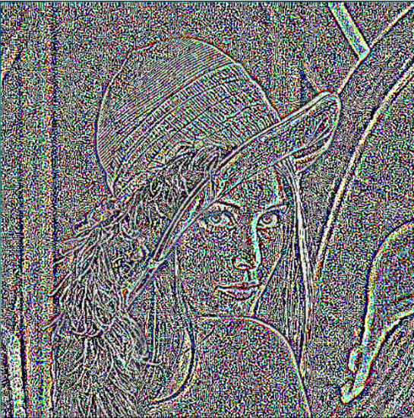

**Fig 1.38:** Laplacian Filtered RGB Image.

**HSV Images:**

The center of the kernel is (0,0).

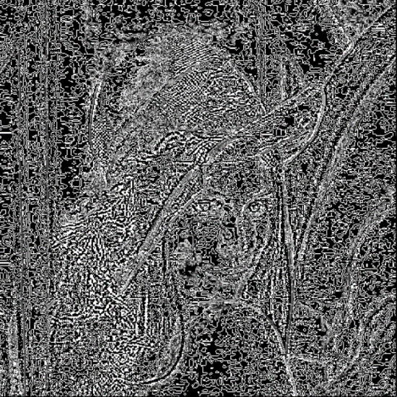

**Fig 1.39:** HSV Image. **Fig 1.40:** Laplacian Filtered Blue Image.

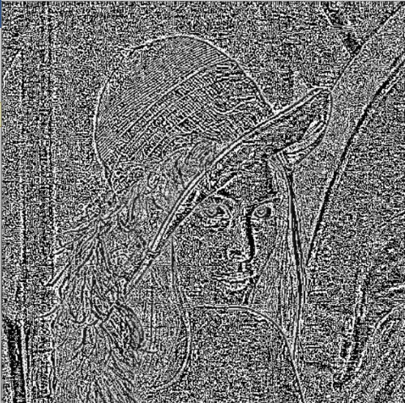 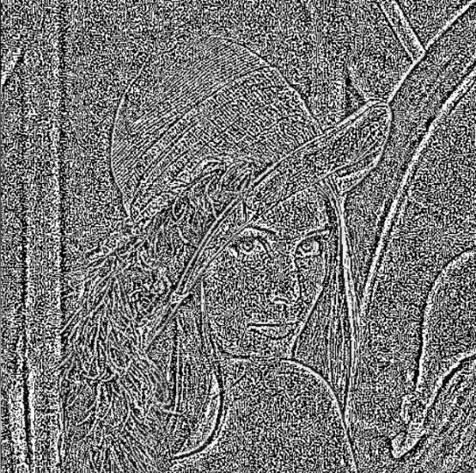

**Fig 1.41:** Laplacian Filtered Green Image. Fig 1.42: Laplacian Filtered Red Image.

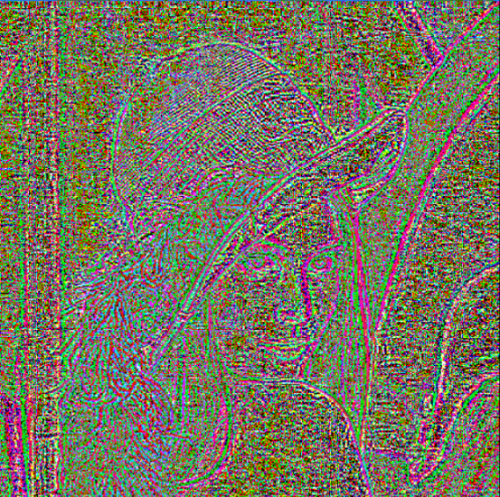

Fig 1.43: Laplacian Filtered HSV Image.

**2.2Sobel Filter**

**Sobel kernel:**

**Horizontal kernel Vertical kernel**

|  |  |  |
| --- | --- | --- |
| -1 | 0 | 1 |
| -2 | 0 | 2 |
| -1 | 0 | 1 |

|  |  |  |
| --- | --- | --- |
| -1 | -2 | -1 |
| 0 | 0 | 0 |
| 1 | 2 | 1 |

**Code Snippet:**

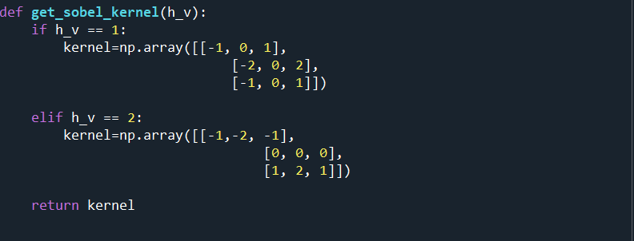

**Output:**

**Grayscale Images:**

The center of the kernel is (1,1).

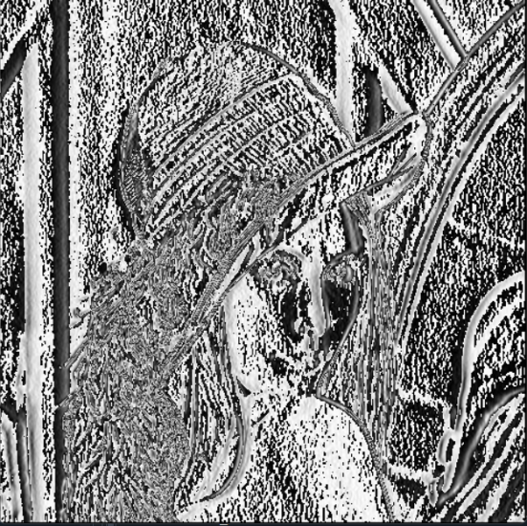 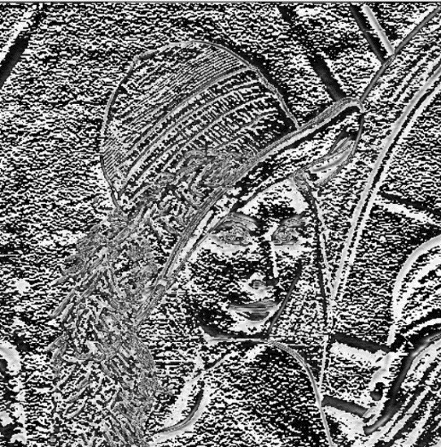

**Fig 1.44:** Sobel Filtered Grayscale Image **Fig 1.45:** Sobel Filtered Grayscale Image

(Horizontal). (Vertical).

**RGB Images:**

The center of the kernel is (1,1).

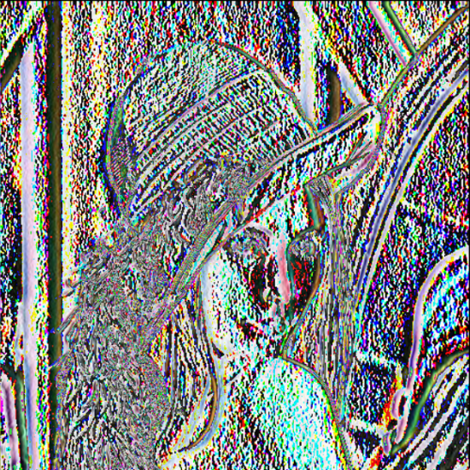 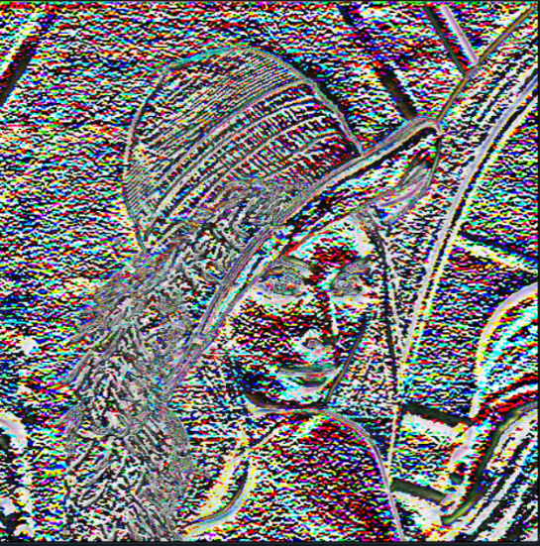

**Fig 1.46:** Sobel Filtered RGB Image (Horizontal) **Fig 1.47:** Sobel Filtered RGB Image

(Vertical).

**HSV Images:**

The center of the kernel is (1,1).

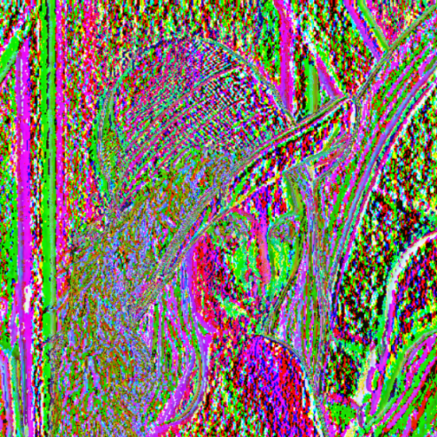 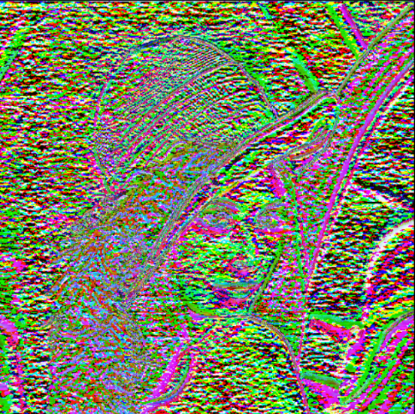

**Fig 1.48:** Sobel Filtered HSV Image (Horizontal). **Fig 1.49:** Sobel Filtered HSV Image

(Verticle).

**2.3. Laplacian of Gaussian (LOG)**

**The Equation of the LoG kernel is:**

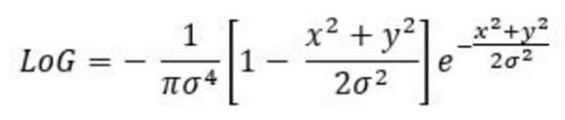

**Kernel Code Snippet:**

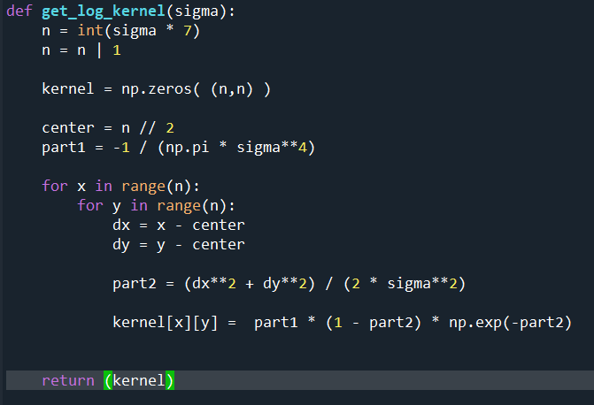

**Gray Scale Images:**

**The kernel center is (1,1) and the value of the sigma is 0.6.**

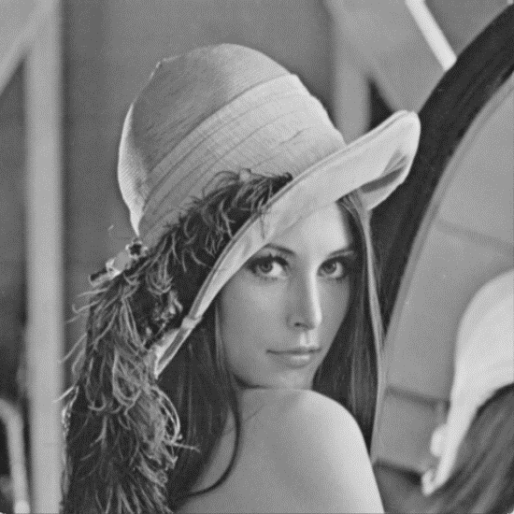 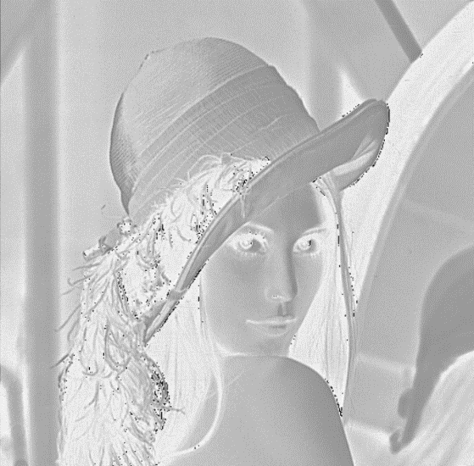

**Fig 1.50:** Gray Scale Image. Fig 1.51: LoG Filtered Gray Scale Image.

RGB Images:

The kernel center is (1,1) and the value of the sigma is 0.6.

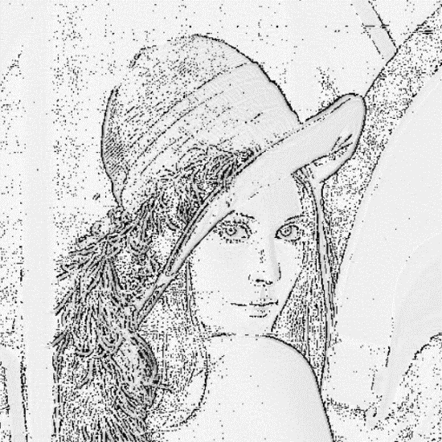 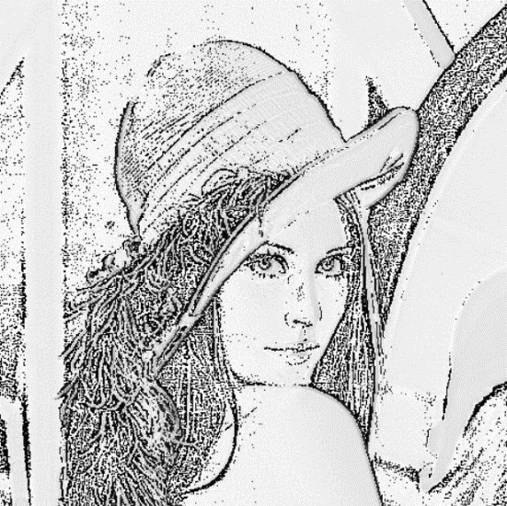

Fig 1.52: LoG Filtered Blue Image. Fig 1.53: Log Filtered Green Image.

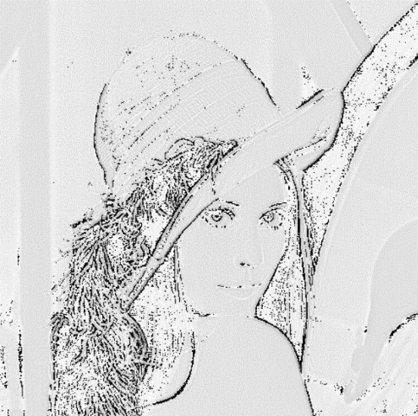 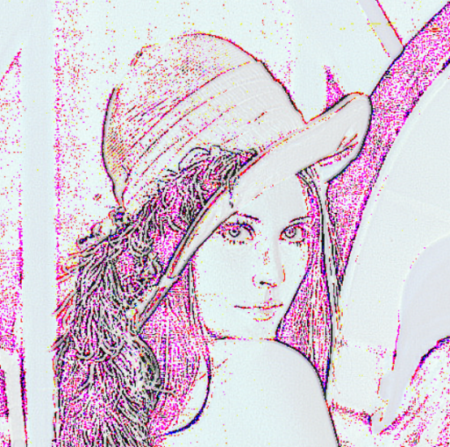

Fig 1.54: Log Filtered Red Image. Fig 1.55: Log Filtered RGB Image.

HSV Images:

The center is (1,1) and sigma is 0.6.

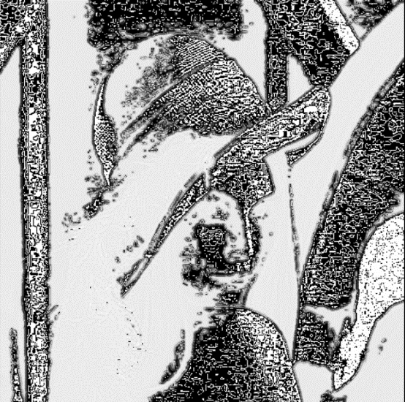 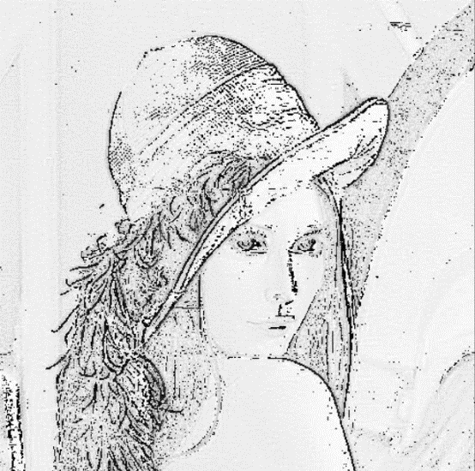

Fig 1.56: LoG Filtered Blue Image. Fig 1.57: LoG Filtered Green Image.

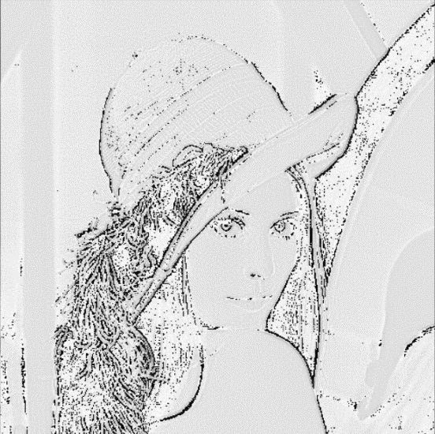 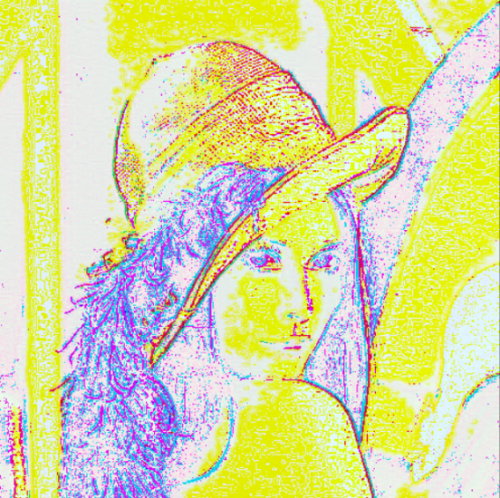

Fig 1.58: Log Filtered Red Image. Fig 1.59:Log Filtered HSV Image.

Difference Between RGB Convoluted Image and HSV Convoluted Image using Gaussian Filter:

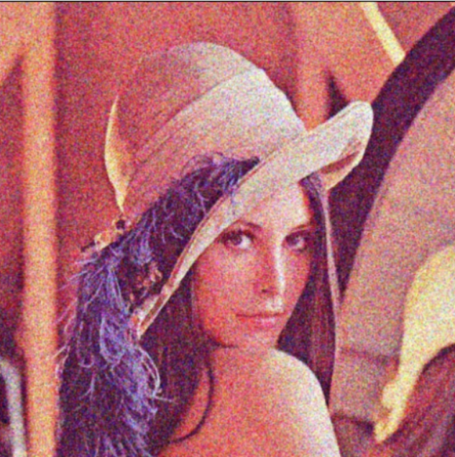 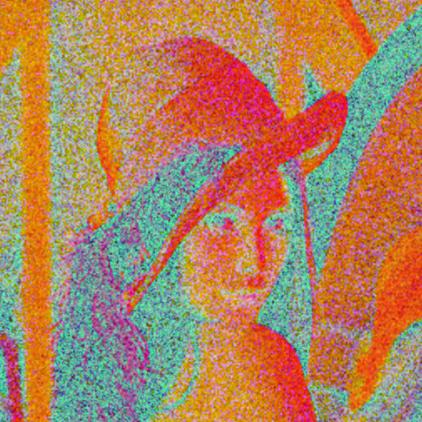

Fig 1.60: RGB Convoluted Image. Fig 1.61: HSV Convoluted Image.

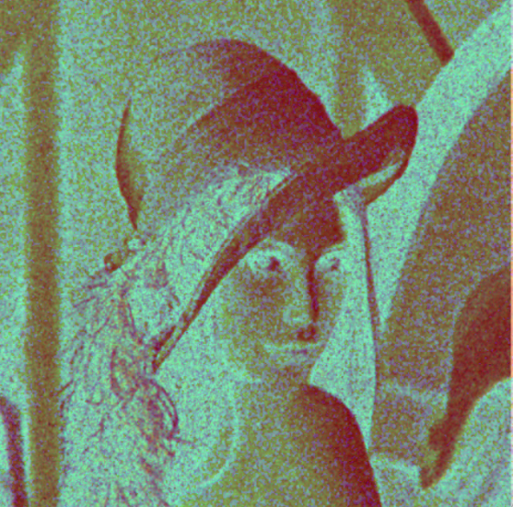

Fig 1.62: Subtracted Image.